Engineering Change Notice o f Jaro HQI0805 Series

Date: Mar. 28th , 2012

Dear Valued Customers,

To improve our production efficiency, we are going to modify our HQI0805 series of the dimension “C ” (seated height) from 1.52mm to 1.56mm. This change will not affect electrical performance.

This ECN is effective for new orders as of May 2012 .
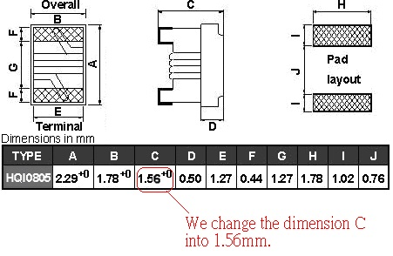
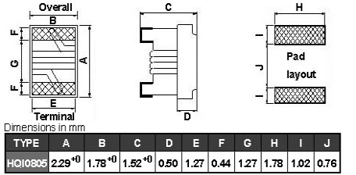

Before After

Wes Archer
Quality Assurance Manager
Jaro Components, Inc.
6600 Park of Commerce Blvd.
Boca Raton 33487

